DATAWARE HOUSING AND DATA MINING

ASSIGNMENT 2

GROUP MEMBERS

MUHAMMAD BILAL AHMED (FA20-BCS-041)

MUHAMMAD SALMAN (SP20-BCS-131)

1. **Data generation**

We generated data using mockaroo. It allows you to quickly and easily to download large amount of randomly or sequentially generated data based own our own specs. This data can be saved in mockaroo’s dataset and can be downloaded into csv file. Using bulk query, we can insert data from csv file to SQL tables.

We generated data of 6 years (2016-2021)

* Customer 1000 rows
* Order 6000 rows
* Order line 21000 rows
* Employees 4 rows
* Purchases 864 rows
* Purchases details 864 rows
* Address 21 rows
* Supplier 4 rows
* Products 12 rows
* Category 8 rows
* Salary 4 rows

1. **Example from SQL Server**

**Supplier**

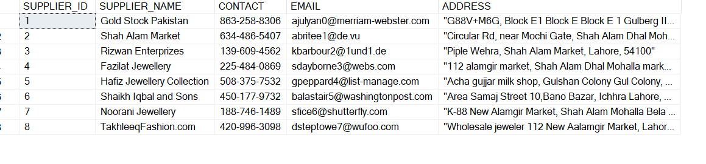

**Purchases**

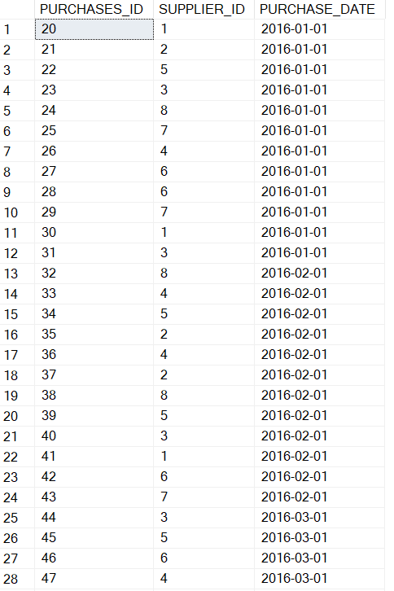

**Product Category**

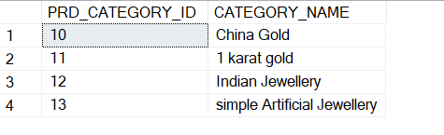

**Products**

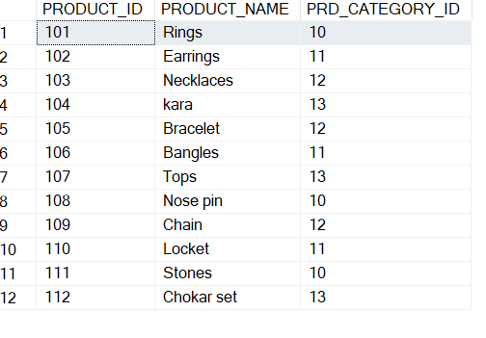

**Purchase Details**

**Customers**

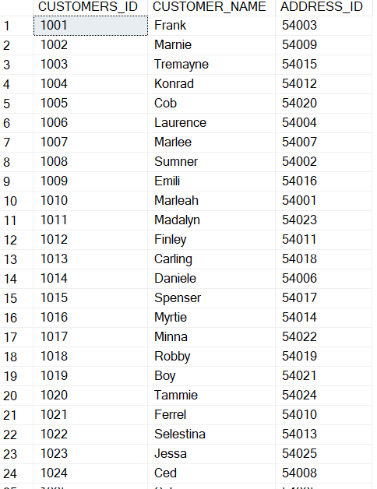

**Order**

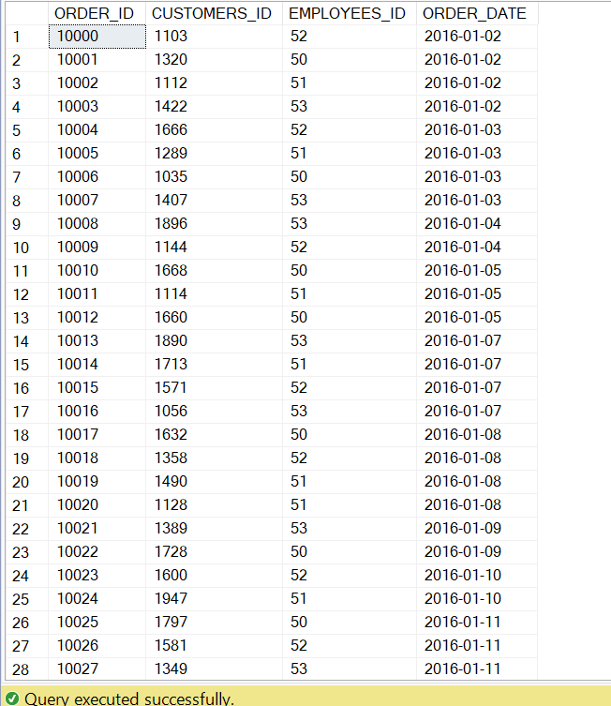

**Order line**

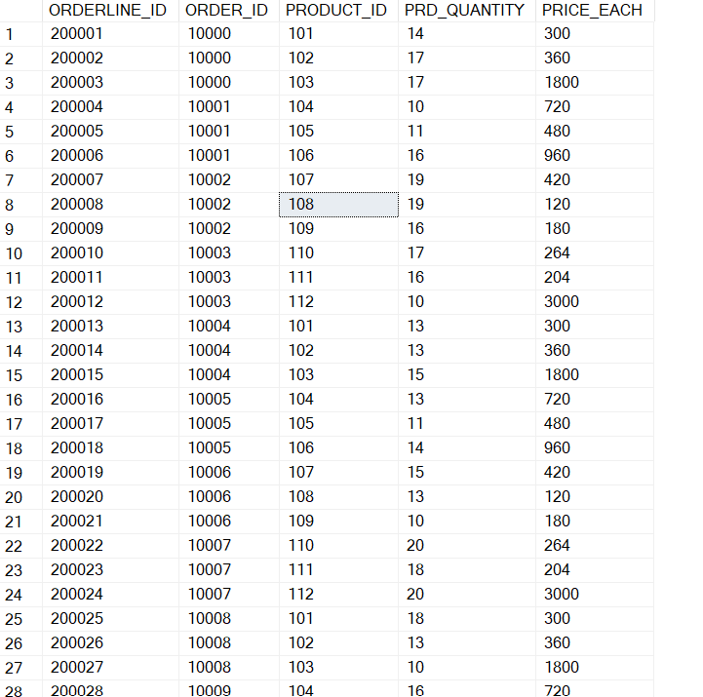

**Address line**

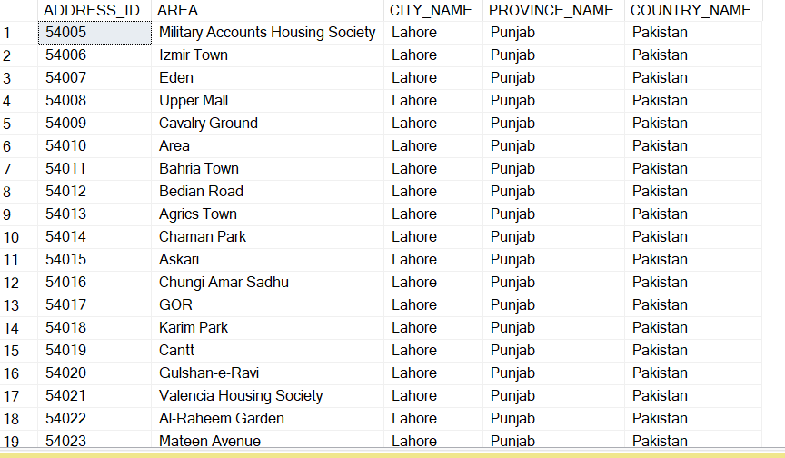

**Employees**

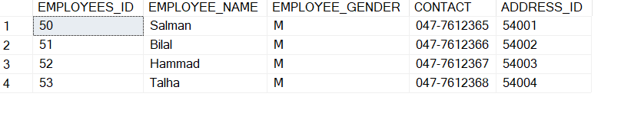

**Salary**

